Independent reanalysis of a single-cell transcriptomic atlas of the cocaine-exposed Drosophila brain

A reproduction and verification study of Baker et al. (2021), GEO: GSE152495

Mahabubur Rahman

Student Project 2 — single-cell RNA-seq analysis

2026-09-15

Contents

(Right-click and choose "Update Field" in Word to populate.)

Abstract

Acute cocaine consumption alters gene expression across the Drosophila melanogaster brain in a manner that is cell-type specific and profoundly sexually dimorphic (Baker et al. 2021). We reanalysed the underlying single-cell data (GEO: GSE152495; eight samples in a 2 × 2 × 2 design of sex × treatment × biological replicate) using an independent Scanpy-based pipeline and subjected the differential expression results to explicit statistical controls that were not applied in the original report.

Quality filtering retained 86,177 cells, within 0.05% of the 86,224 cells reported. Leiden clustering at the published resolution of 0.8 yielded 30 clusters rather than 36; a resolution sweep reached 36 clusters at approximately 1.33, and the reported plateau in the cluster number at a resolution of 0.8 was not observed. Twenty-four clusters were assigned cell-type identities using two independent marker panels, including populations corresponding to the Kenyon cells, surface glia, and unannotated antennal/optic lobe clusters.

The reported male bias in transcriptional response was reproduced; however, its magnitude was strongly dependent on how it was computed: 6.43-fold with cells pooled within each sex, 1.65-fold summed across clusters, and 0.97-fold counting unique genes (published value 2.15-fold). Excluding mitochondrial, respiratory-chain, and ribosomal transcripts left the pooled ratio unchanged but reduced the cluster-level ratio to 1.13-fold. No gene showed a significant sex × treatment interaction in the pseudobulk model.

Comparing the treatment contrast against alternative groupings of the same samples revealed an asymmetry not detectable from gene counts alone. In males, the true treatment split yielded 90 differentially expressed genes against 7 and 14 for two null contrasts. In females, it yielded 14 against 39 and 35, fewer genes than any incorrect grouping of the same four samples, with 64% of them also appearing in a null contrast. The replicate axis was the largest source of variation in the female data.

The design-level conclusions of the original study have been reproduced. However, the female response is not resolvable above the between-sample variation in these data, and the reported sexual dimorphism may substantially reflect a male response detectable above background alongside a female response that is not.

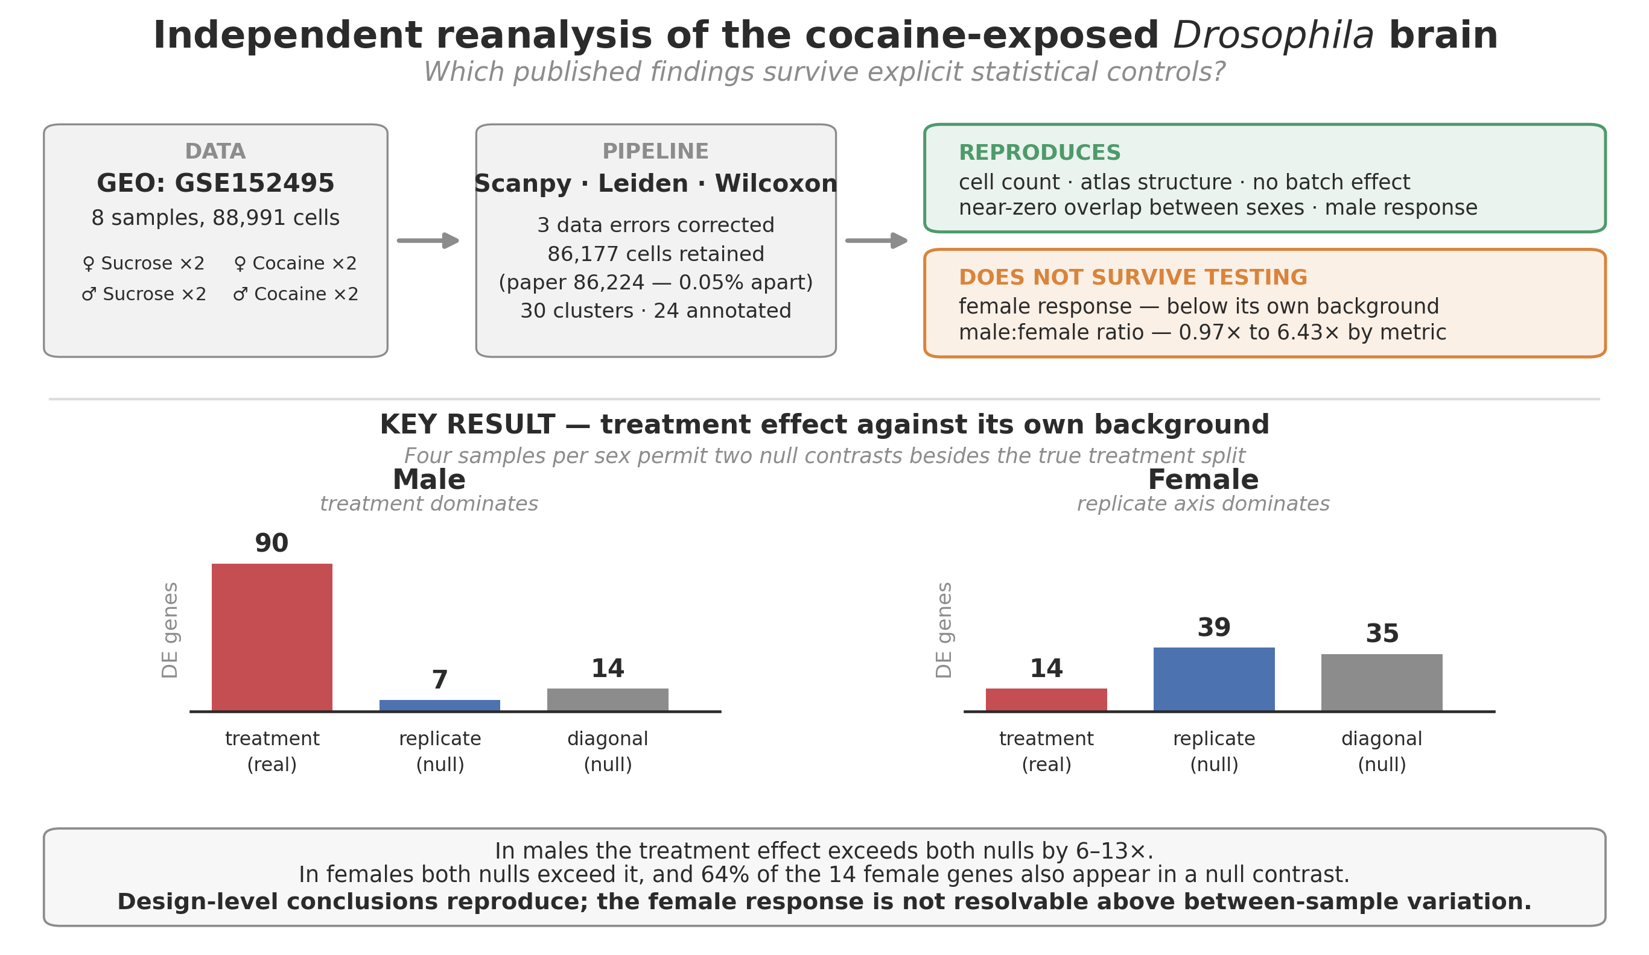

Graphical abstract. The reanalysis pipeline, findings that reproduce, and key control: in males, the treatment effect exceeds both null contrasts; in females, both exceed it.

1. Introduction

1.1 Drosophila as a model for psychostimulant response

Cocaine acts principally by blocking monoamine reuptake. Its molecular targets are conserved in invertebrates: the Drosophila dopamine transporter has been crystallised with a binding site that accommodates cocaine (Wang et al. 2015), a cocaine-sensitive serotonin transporter has been cloned and characterised electrophysiologically (Corey et al. 1994), and overexpression of the vesicular monoamine transporter in dopaminergic and serotonergic neurones decreases the behavioural response to the drug (Chang et al. 2006). Approximately 75% of human disease-causing genes have fly orthologues (Pandey and Nichols 2011), and the fly has been argued to be a tractable system for the systems genetics of drug consumption (Kaun et al. 2012).

Behaviourally, flies exposed to cocaine display stereotypic motor responses and develop sensitisation to repeated intermittent exposure (McClung and Hirsh 1998; Filošević et al. 2018). Mutants of moody, which encodes two G protein-coupled receptor isoforms localised to surface glia, show increased sensitivity to cocaine (Bainton et al. 2005), indicating early that the response is not restricted to neurons.

Sex differences in psychostimulant responses have been well documented in mammals. Women escalate drug use to the compulsive stage more rapidly than men (Westermeyer and Boedicker, 2000; Haas and Peters, 2000) and show greater relapse rates (Becker and Koob, 2016), whereas men experience the effects of cocaine faster and more intensely at equal doses (Lukas et al., 1996).

Studies using the Drosophila Genetic Reference Panel (Mackay et al. 2012; Huang et al. 2014) identified candidate genes associated with variation in cocaine consumption and preference, implicating dopaminergic neurones and mushroom bodies — central structures underlying experience-dependent modification of behaviour — as well as glia (Highfill et al. 2019).

1.2 The case for single-cell resolution

Bulk transcriptomic profiling of the whole brain averages the expression across all cell types present. A response confined to a single population is diluted by the non-responding majority and may fall below detection; opposing responses in different populations can be cancelled entirely. Single-cell RNA sequencing removes this averaging, and the adult fly brain is small enough to be surveyed in a single experiment. Reference atlases of the adult and aging Drosophila brains already exist (Croset et al., 2018; Davie et al., 2018), providing marker sets against which new clusters can be annotated.

1.3 The study reanalysed here

Baker et al. (2021) applied this approach to acute cocaine consumption. Flies of both sexes consumed a fixed volume (0.53 µL) of sucrose or cocaine-supplemented sucrose in a modified capillary feeder assay (Ja et al. 2007); brains were dissected immediately and dissociated using a protocol modified from Croset et al. (2018) and Davie et al. (2018). Eight samples of 20 brains each — two biological replicates per sex per treatment — were processed on the 10x Genomics Chromium platform. Processing used CellRanger v3.1 against D. melanogaster Release 6, then Seurat v3 (Butler et al. 2018) with SCTransform normalisation (Hafemeister and Satija 2019), shared-nearest-neighbour clustering at resolution 0.8, UMAP visualisation (Becht et al. 2019), and MAST for differential expression.

The principal conclusions were: that unsupervised clustering of 86,224 cells yielded 36 stable clusters spanning all major neuronal and glial classes; that acute cocaine elicits rapid, widespread transcriptional change; that responses are cell-type specific, with Kenyon cells (their C11, C20) and glia (C17, C22) among the strongest responders; and that the response is profoundly sexually dimorphic, with 691 differentially expressed genes in males and 322 in females, with little overlap between the sexes.

1.4 Rationale: reproduction is not verification

The reanalysis of deposited data serves two distinct purposes that are worth separating.

Reproduction asks whether an independent pipeline recovers the published result. A finding that survives Scanpy, Seurat, Leiden, shared-nearest-neighbour clustering, and Wilcoxon and MAST is more robust than one demonstrated once.

Verification asks whether the published conclusions are supported by the data as analysed. These can come apart. Differential expression in single-cell data is vulnerable to several confounds that are not visible in a published figure but are detectable in the deposited data. Cells from one animal are not statistically independent; therefore, treating thousands of cells from two animals as thousands of observations inflates significance — a form of pseudoreplication shown to generate hundreds of differentially expressed genes in the complete absence of biological differences (Squair et al. 2021; Zimmerman et al. 2021). Free RNA from lysed cells partitions into droplets and is misattributed to intact cells (Young and Behjati 2020). Systematic differences in dissociation quality or capture efficiency between experimental groups produce expression differences that are technically but statistically indistinguishable from biological ones.

Each requires a specific test. This reanalysis applies to them.

2. Methods

2.1 Data and pre-analysis corrections

Count matrices for GSE152495 were pre-processed as eight CellRanger v3 output directories. Three problems were identified and corrected before the analysis; each would have propagated silently.

Delimiter. The supplied features.tsv.gz files were space- rather than tab-delimited, which scanpy.read_10x_mtx cannot parse. Fields were collapsed into one column, and gene-symbol assignment failed. Files were converted with field content unchanged (17,481 lines per file), and the originals were retained.

Gene nomenclature. The gene nanchung (Dmel_CG5842, FlyBase symbol nan) is interpreted by pandas as a missing value rather than text, leaving one gene unnamed and preventing HDF5 serialisation. It was renamed CG5842. The related gene narrow abdomen (na, Dmel_CG1517) was unaffected, as lowercase na was not in the default missing-value list.

The reference additionally substituted vertebrate orthologue names for five fly symbols, resolved by gene ID against FlyBase (Thurmond et al. 2019): VGlut1 = VGlut (CG9887), Adcy1 = rut (CG9533), Pde4 = dnc (CG32498), Trhn = Trh (CG9122), Tret1 = Tret1-1 (CG30035). Critically, trh (lowercase) in this reference is CG42865, trachealess — an unrelated tracheal transcription factor. Marker matching was therefore performed case-sensitively; a case-insensitive match would have labelled a cluster serotonergic on the basis of a tracheal gene.

Sample labels. Sex-specific markers separated the eight samples into two groups of four, but the split followed the treatment field of the folder name rather than the sex field. The male panel (roX1, roX2, MSL complex) gave a 10.6-fold non-overlapping separation by treatment label and 1.0-fold by sex label; the female panel (Sxl, Yp1–Yp3, tra) gave 2.1-fold and 1.2-fold, respectively. Yolk proteins read 0.000–0.001 in all four samples labelled sucrose and 0.028–0.422 in all four labelled cocaine; as yolk proteins are transcribed only in females, this cannot be a drug effect.

Sample identities were reconstructed from the deposition order given in the authors’ published analysis code, which lists S1–S2 as female sucrose, S3–S4 as male sucrose, S5–S6 as female cocaine, and S7–S8 as male cocaine. Pairing that order against the supplied folder names sorted alphabetically reproduces the observed marker pattern for all eight samples. Four sex labels and four treatment labels were corrected. After correction, roX1 reads 3.898 in males versus 0.074 in females and Yp1–Yp3 are approximately 100-fold higher in females. Sex assignment is confirmed by marker evidence; treatment assignment is inferred from deposition order, as no marker gene reports drug consumption.

Table 1. Corrected sample identity. Four sex labels and four treatment labels differ from the folder names supplied.

Folder as supplied | GEO position | True sex | True treatment
Female_Cocaine_1 | S1 | Female | Sucrose
Female_Cocaine_2 | S2 | Female | Sucrose
Female_Sucrose_1 | S3 | Male | Sucrose
Female_Sucrose_2 | S4 | Male | Sucrose
Male_Cocaine_1 | S5 | Female | Cocaine
Male_Cocaine_2 | S6 | Female | Cocaine
Male_Sucrose_1 | S7 | Male | Cocaine
Male_Sucrose_2 | S8 | Male | Cocaine

2.2 Quality control

Cells with fewer than 300 or more than 2,500 detected genes were removed, following the original study’s criteria, as were cells exceeding 10% mitochondrial reads and genes detected in fewer than five cells. Mitochondrial genes were identified by the mt: prefix and ribosomal genes by RpS/RpL. A total of 86,177 of 88,991 cells (96.8%) and 12,189 of 17,481 genes were retained.

2.3 Normalisation, dimensionality reduction and clustering

Counts were normalised to 10,000 per cell and log1p-transformed; the log-normalised matrix was retained for differential analysis. Two thousand highly variable genes were selected using per-sample ranking. The matrix was subset to these genes, total_counts and pct_counts_mt were regressed out, and the values were scaled to unit variance with a maximum of 10. Principal component analysis used the ARPACK solver; the first 30 components (16.9% of variance) were used for a 15-nearest-neighbour graph and UMAP. Leiden clustering (Traag et al. 2019) was performed at a resolution of 0.8, with a sweep across 0.4–1.4. All stochastic steps used fixed random seeds.

2.4 Cell-type annotation

Cluster markers were identified using the Wilcoxon rank-sum test on log-normalised values. Cell types were assigned using two independent panels: the published top-three markers for each of the original 36 clusters and a canonical Drosophila neuronal and glial panel. Where the panels disagreed, the clusters were left unannotated. Of the 30 clusters, 24 were assigned; 13,526 cells (15.7%) remained unannotated.

One cluster (n = 3,196) was excluded from the differential expression analysis. It showed mixed neuronal and glial markers (repo 0.200, elav 1.06, nSyb 2.19) and a 1.50-fold difference in median detected genes between treatment arms and the largest of any cluster — rendering its 299 differentially expressed genes uninterpretable.

2.5 Differential expression

Cocaine was compared with sucrose by Wilcoxon rank-sum test on log-normalised values with sucrose as reference, so positive log2 fold changes indicate higher expression in cocaine. Genes were called differentially expressed at |log2FC| > 1 and Benjamini–Hochberg-adjusted p < 0.05. The original used a natural-log threshold (|ln FC| > 1, equivalent to |log2FC| > 1.443) with Bonferroni correction and the MAST test; gene counts are therefore not directly comparable, and results are reported at both thresholds where relevant.

Three comparisons were performed: pooled across all cells within each sex, within each cluster and sex separately, excluding clusters with fewer than 20 cells in either arm, and overlap between sexes.

2.6 Statistical controls

Pseudobulk aggregation. Counts were summed within each sample to obtain one profile per biological replicate, converted to log2 counts per million, and compared by two-sample t-test with Benjamini–Hochberg correction (n = 2 per arm). Concordance with the cell-level result was assessed by sign agreement and Spearman ’scorrelation.

Interaction model. For each gene, expression was modelled as sex + treatment + sex:treatment by ordinary least squares on pseudobulk profiles using effect coding, and the interaction coefficient was tested. This addresses the fact that a gene significant in one per-sex analysis and not the other has not been shown to differ between them (Gelman and Stern 2006).

Gene-class exclusion. Pooled differential expression was repeated with mitochondrial, respiratory chain, and ribosomal genes progressively removed.

Cluster-size matching. Every cluster was downsampled to 400 cells, and differential expression was repeated over three random seeds.

Permutation control. Within each sex, the four samples permit six 2-versus-2 splits: the true treatment split, its complement, and four cuts across the treatment assignment. Excluding complementary duplicates leaves two independent null contrasts per sex — the replicate axis (both replicate-1 samples versus both replicate-2) and a diagonal pairing. Each was tested with identical cells, tests, and thresholds, providing a background against which the treatment effect could be judged.

2.7 Pathway enrichment

Over-representation analysis used GSEApy against the Enrichr Drosophila libraries (GO Biological Process 2018, GO Molecular Function 2018, KEGG 2019). Up- and down-regulated genes were tested separately, up to 150 genes per list. Enrichr tests against all annotated fly genes, whereas the differential expression test could only detect brain-expressed genes surviving quality control; therefore, adjusted p-values are optimistic for brain-expressed terms.

2.8 Software

Python 3.11.15 with scanpy 1.11.5 (Wolf et al. 2018), anndata 0.12.19, numpy 2.4.6, pandas 2.3.3, scipy 1.17.1, scikit-learn 1.9.1, statsmodels, python-igraph 1.0.0, leidenalg 0.12.0, umap-learn 0.5.12, gseapy 1.3.1, and matplotlib 3.11.2. The environment was managed with uv; a complete lockfile and all analysis code are included in this report.

2.9 Workflow overview

The complete analysis is summarised in Figure 1. Bracketed numbers correspond to the numbered scripts in the accompanying repository; therefore, every result in Section 3 can be traced to the step that produced it.

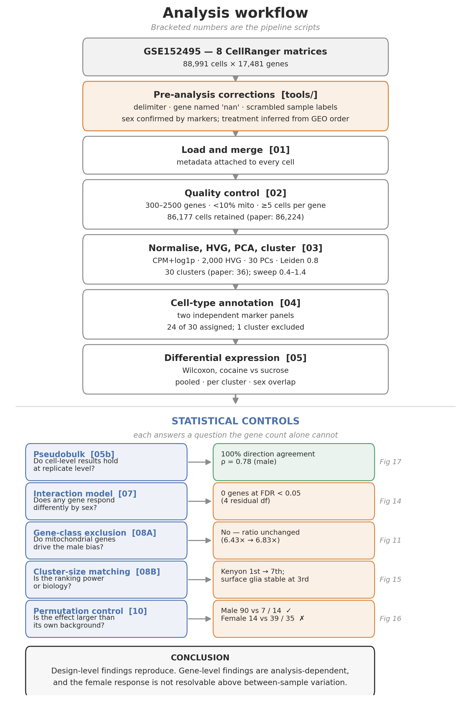

Figure 1. Analysis workflow. The upper column shows the processing pipeline; the lower panel lists the five statistical controls applied to the differential expression results, each with the question it answers, its outcome, and the figure reporting it. Green indicates a control the result passed; amber indicates one it did not.

3. Results

3.1 Quality control reproduces the published cell count

After filtering, 86,177 cells were retained from 88,991 (96.8%), against the 86,224 reported by Baker et al., a difference of 47 cells (0.05%). The gene count fell from 17,481 to 12,189. The close agreement indicates that the filtering criteria and input data were correctly identified.

Sequencing depth varied approximately two-fold between samples (median, 675–1,195 genes per cell). Depth was not confounded with treatment; within each sex, one deeper and one shallower replicate fell in each arm.

The mitochondrial fraction differed systematically between treatment arms in males but not in females. The median mitochondrial percentage was 0.373% in male cocaine samples against 0.058% in male sucrose — a 6.4-fold difference — while the female values were 0.260% and 0.267%, respectively.

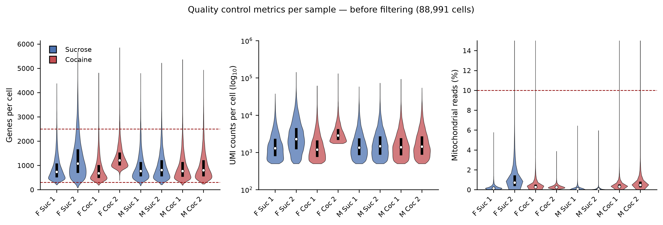

Figure 2. Quality-control metrics per sample before filtering (88,991 cells). Violins show the distribution per sample, coloured by treatment; black bars mark the interquartile range, and white points the median. Dashed lines indicate filter thresholds. Panel 3 shows the male-specific difference in mitochondrial content between treatment arms; note that the y-axis is capped at 15% to make the bulk of the distribution visible.

3.2 Clustering recovers 30 populations; 24 were assignable

Leiden clustering at resolution 0.8 yielded 30 clusters against 36 reported. A resolution sweep gave a monotonic increase (19, 24, 30, 33, 34, 37 at resolutions 0.4 to 1.4), reaching 36 at approximately 1.33. The published stability argument — that cluster count plateaus at resolution 0.8 — was not reproduced; cluster number rose steadily across the range tested.

The embedding was not driven by batch, sex, or treatment. Only one of the 30 clusters exceeded 30% composition from a single sample (34.3%, against 12.5% expected under even mixing), and that cluster was shown to be a genuine female-biased population rather than a batch artefact: it remained 74.5% female among depth-matched cells against a 56.4% background. Treatment composition was tight (overall 51.8%; maximum 68.7%); sex composition ranged from 22.2% to 71% (overall 49.2%).

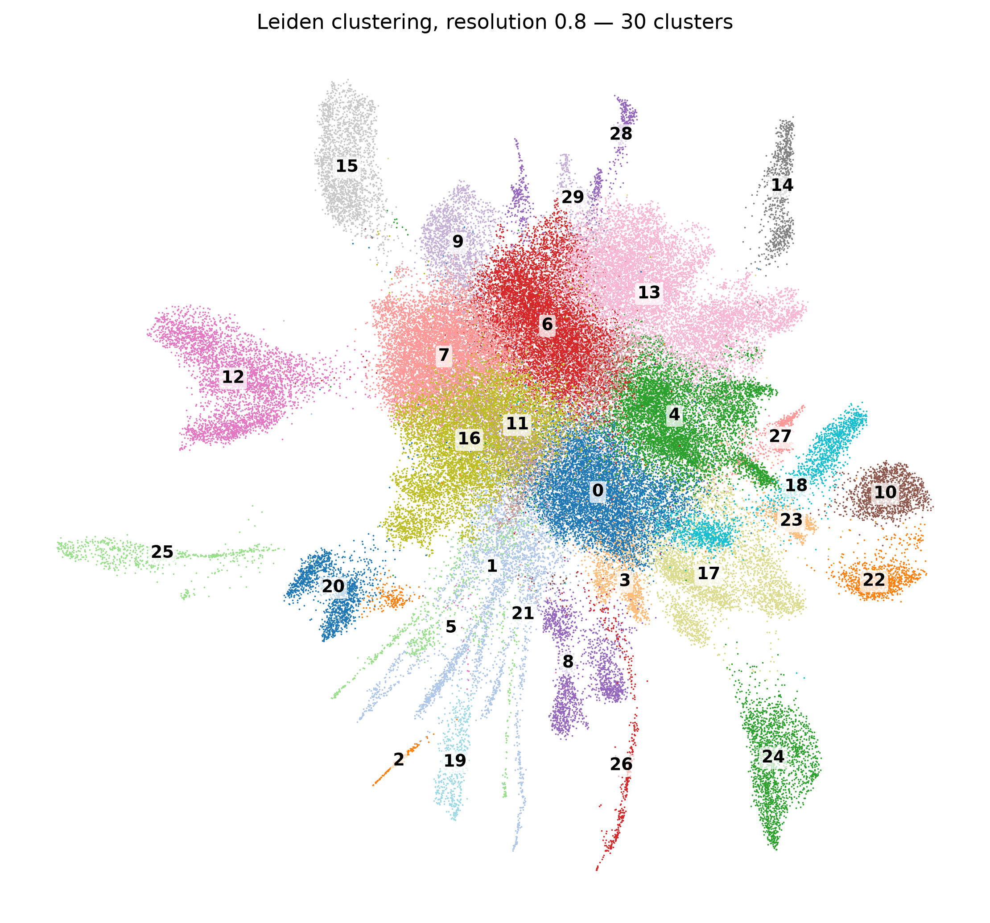

Figure 3. UMAP embedding of 86,177 cells coloured by Leiden cluster (resolution 0.8, 30 clusters). Numbers mark cluster centroids. Radiating filamentous structures reflect low-depth cells and are a known artefact of UMAP embedding rather than biological structure.

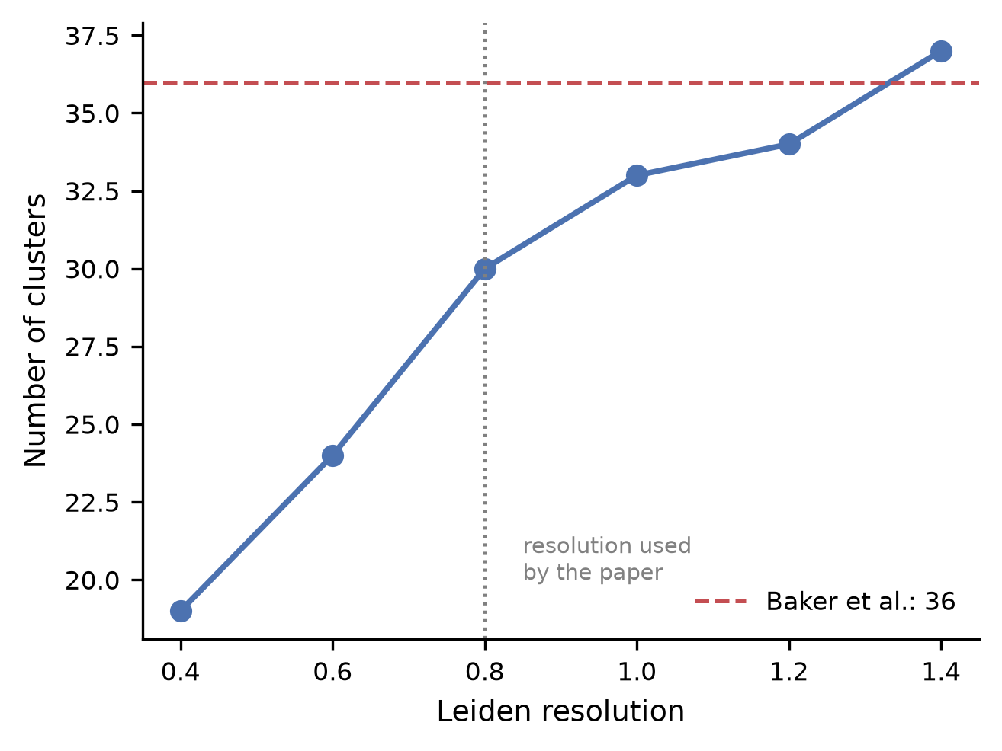

Figure 4. Cluster number as a function of the Leiden resolution. The count increases monotonically with no plateau at the resolution used in the original study (dotted line); 36 clusters are reached at a resolution of approximately 1.33.

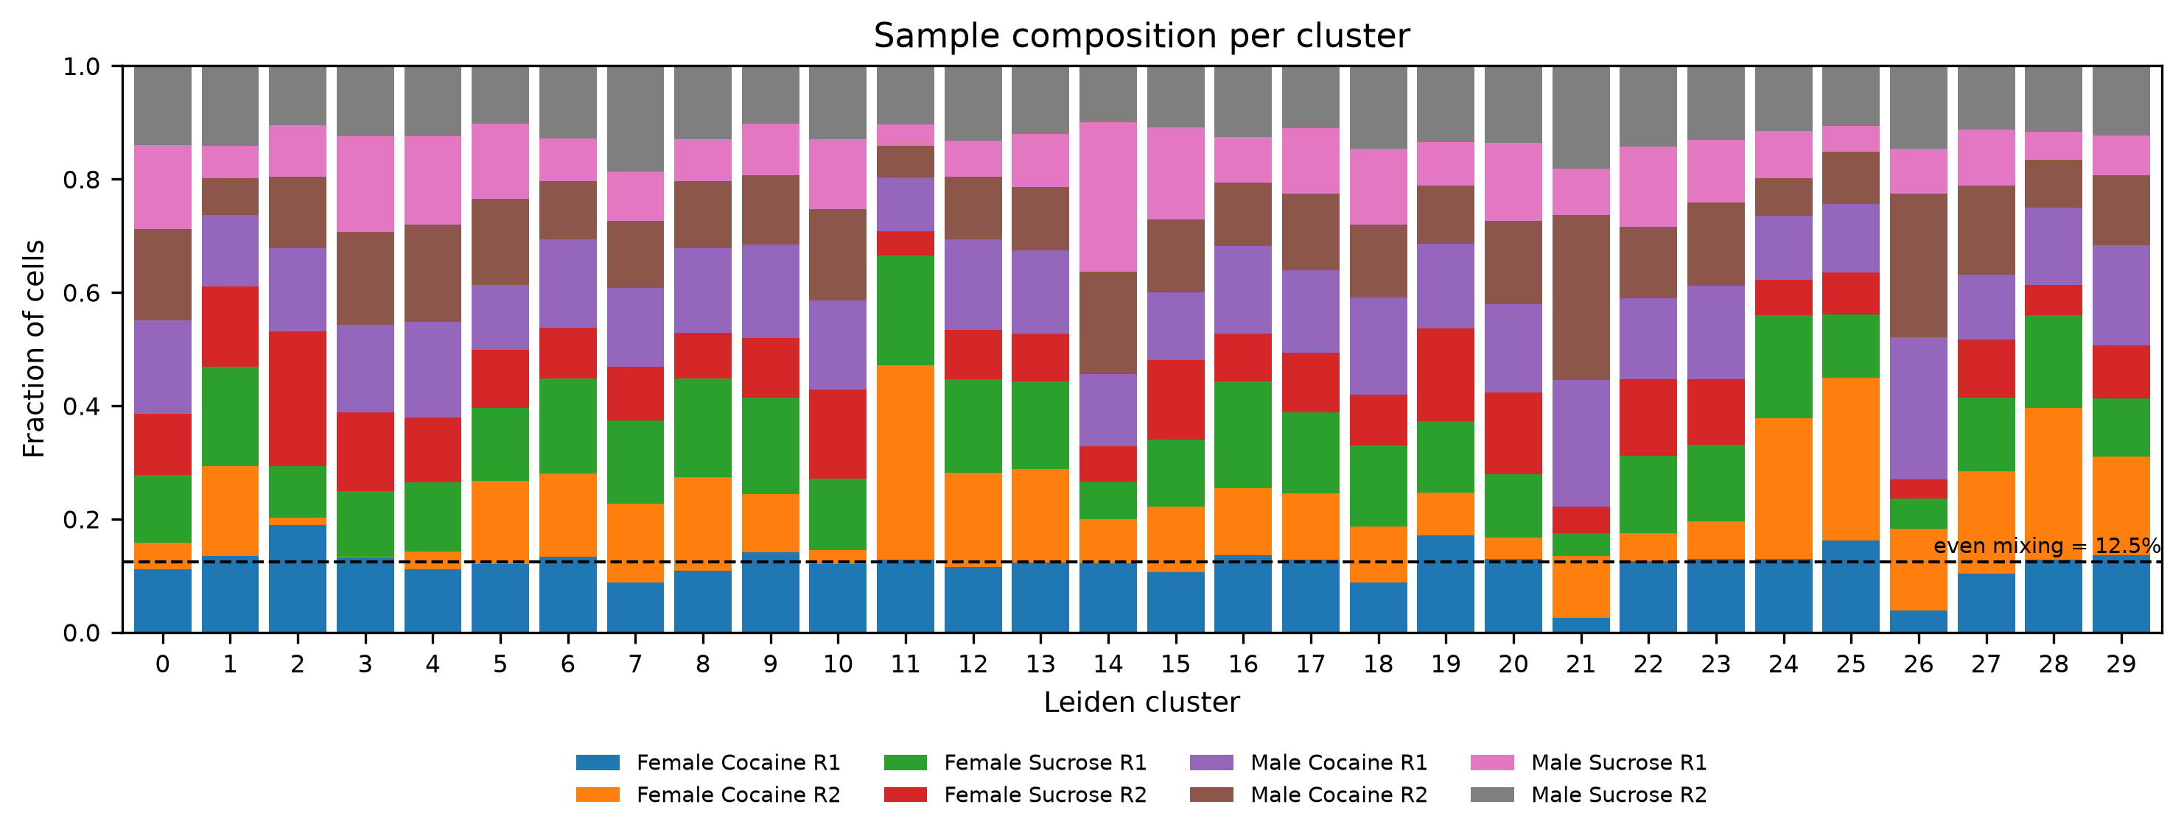

Figure 5. Sample composition of each cluster. The dashed line marks 12.5%, the expected value under even mixing of eight samples. Only cluster 11 exceeds 30% from a single sample.

Twenty-four clusters received cell-type labels; six were left unannotated (13,526 cells, 15.7%). Four assignments matching the strongest responders in the paper were verified against both marker panels.

Table 2. Correspondence between the strongest responding clusters and those identified here, matched by marker gene rather than cluster number.

Paper cluster | Cell type | This study | Panel score vs. next
C11 | Kenyon cells | cluster 12 | 2.44 vs 2.07
C16 | Unannotated (antennal/optic lobe) | cluster 15 | 2.74 vs 0.96
C22 | Surface glia and fat body | cluster 25 | 2.94 vs 0.96
C17 | Astrocytes | not identified | —

The Kenyon cell assignment illustrates why two panels are necessary. Ranked on the published triplet (jdp/Pka-R2/Rgk1) alone, cluster 28 placed a close second and could plausibly be called a Kenyon subpopulation. The independent panel excluded it: ey reads 1.084 in cluster 12 and 0.017 in cluster 28, which were indistinguishable from the background.

The C17 astrocytes in the paper could not be identified with confidence. Cluster 24 matched on Eaat1 (3.501) and CG15522 but was repo-negative (0.028) and alrm-negative (0.033) with high neuronal markers and was left unannotated. The genuine astrocyte-like population (cluster 2: repo 0.830, alrm 4.106, Gs2 4.829, Eaat1 3.642) comprises only 143 cells.

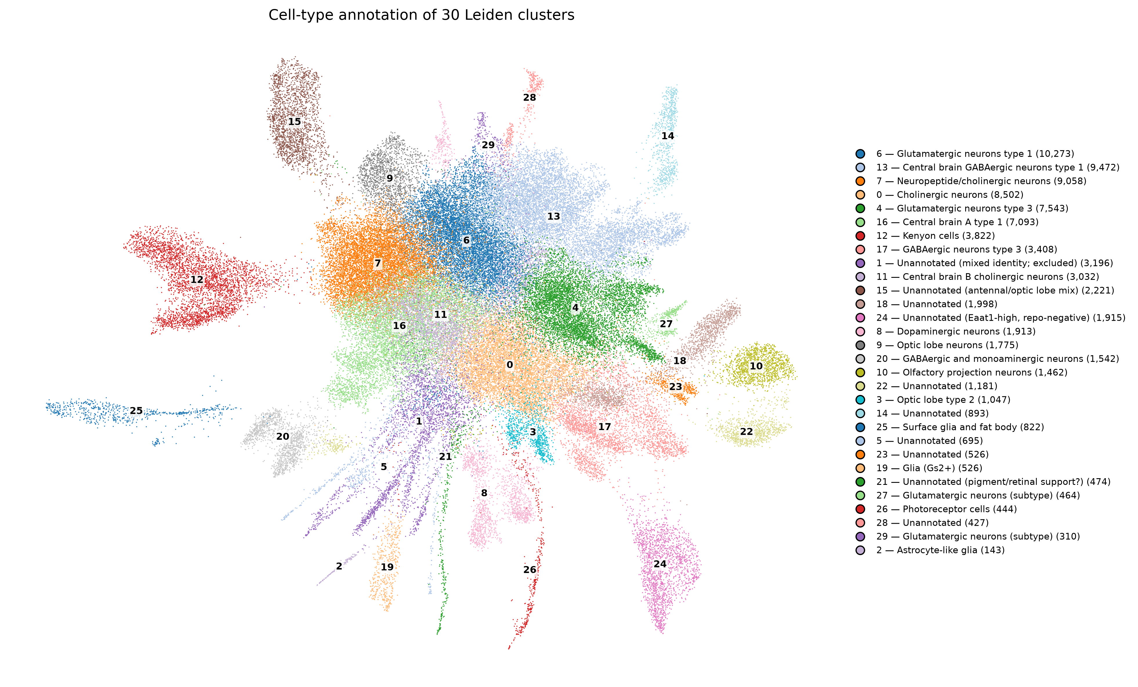

Figure 6. Cell-type annotation of the 30 Leiden clusters. The numbers on the plot correspond to the legend, which lists the cell type and cluster size.

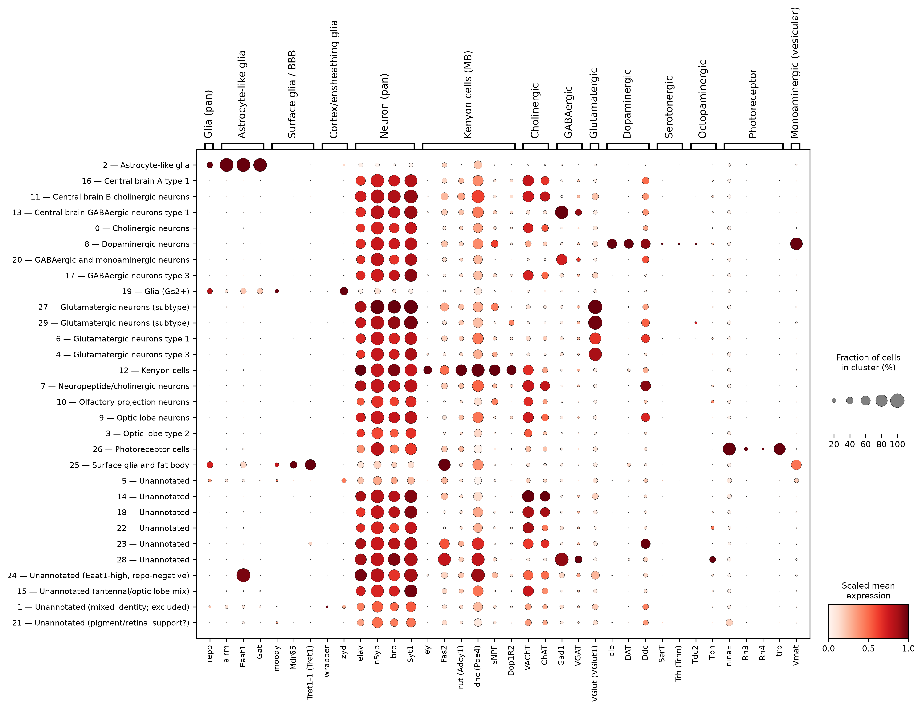

Figure 7. Canonical marker expression by cluster. Rows are labelled by cluster number and assigned cell type; gene names give the fly symbol with the reference’s substituted name in parentheses where they differ. Dot size indicates the fraction of cells expressing; colour indicates scaled mean expression. Note the contrast between cluster 2 (repo, alrm, Eaat1, Gat all high) and cluster 24 (Eaat1 alone).

3.3 The male bias is strongly analysis-dependent

Pooled within each sex, males showed 90 DEGs (87 upregulated, 3 downregulated) and females 14 (12 upregulated, 2 downregulated) — a ratio of 6.43-fold. Baker et al. reported 691 versus 322 (2.15-fold). Computing the same quantity differently yields materially different answers.

Table 3. The male:female ratio of differentially expressed genes under the six analyses of the same corrected data.

Analysis | Male | Female | Ratio
Pooled, all cells per sex | 90 | 14 | 6.43×
Gene × cluster events, |log2FC| > 1 | 616 | 373 | 1.65×
Unique genes, |log2FC| > 1 | 188 | 193 | 0.97×
Gene × cluster events, |log2FC| > 1.443 | 254 | 74 | 3.43×
Unique genes, |log2FC| > 1.443 | 46 | 45 | 1.02×
Baker et al. (MAST, Bonferroni) | 691 | 322 | 2.15×

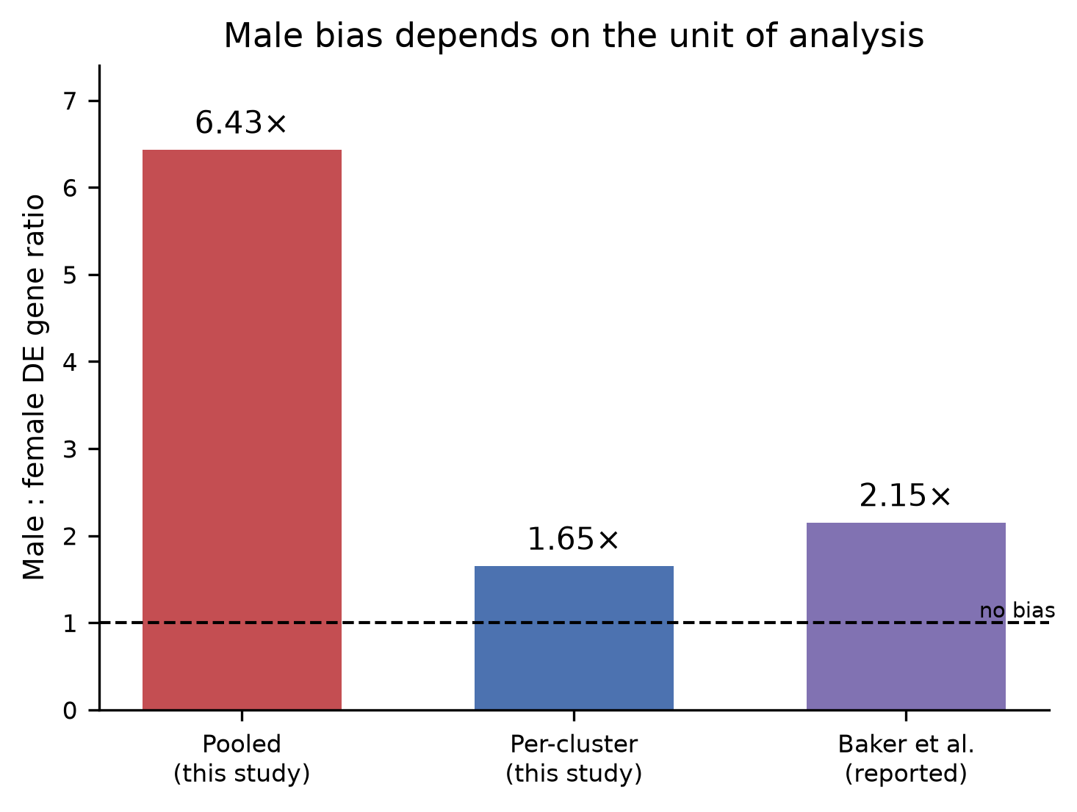

Figure 8. Male:female ratio of differentially expressed genes under three analyses. Pooled: all cells of one sex in a single comparison. Per-cluster: 23 annotated clusters tested separately and summed. Baker et al. reported 691 and 322 from pooled cells using MAST with Bonferroni correction; therefore, the published figure is not directly comparable in test or correction method. Dashed line indicates no sex bias.

Essentially, the same number of unique genes responded in each sex. The asymmetry lies in how many clusters each responding gene affects: mean 3.28 clusters per gene in males against 1.93 in females. This difference is driven by the tails rather than by a general shift — medians were 1 in both sexes and a Mann–Whitney test was non-significant (p = 0.24), with male maxima of 23 clusters against 12 in females.

Female responses were also more concentrated by cell type. Females exceeded males in six of 23 clusters, including Kenyon cells (63 versus 33), the antennal/optic lobe cluster corresponding to C16 (58 versus 17), dopaminergic neurones (51 versus 35), and surface glia (34 versus 14).

Overlap between the sexes was near zero at the pooled level (89 male-only, 13 female-only, 1 shared) and per cluster (Jaccard index 0.000–0.032 across six cell types).

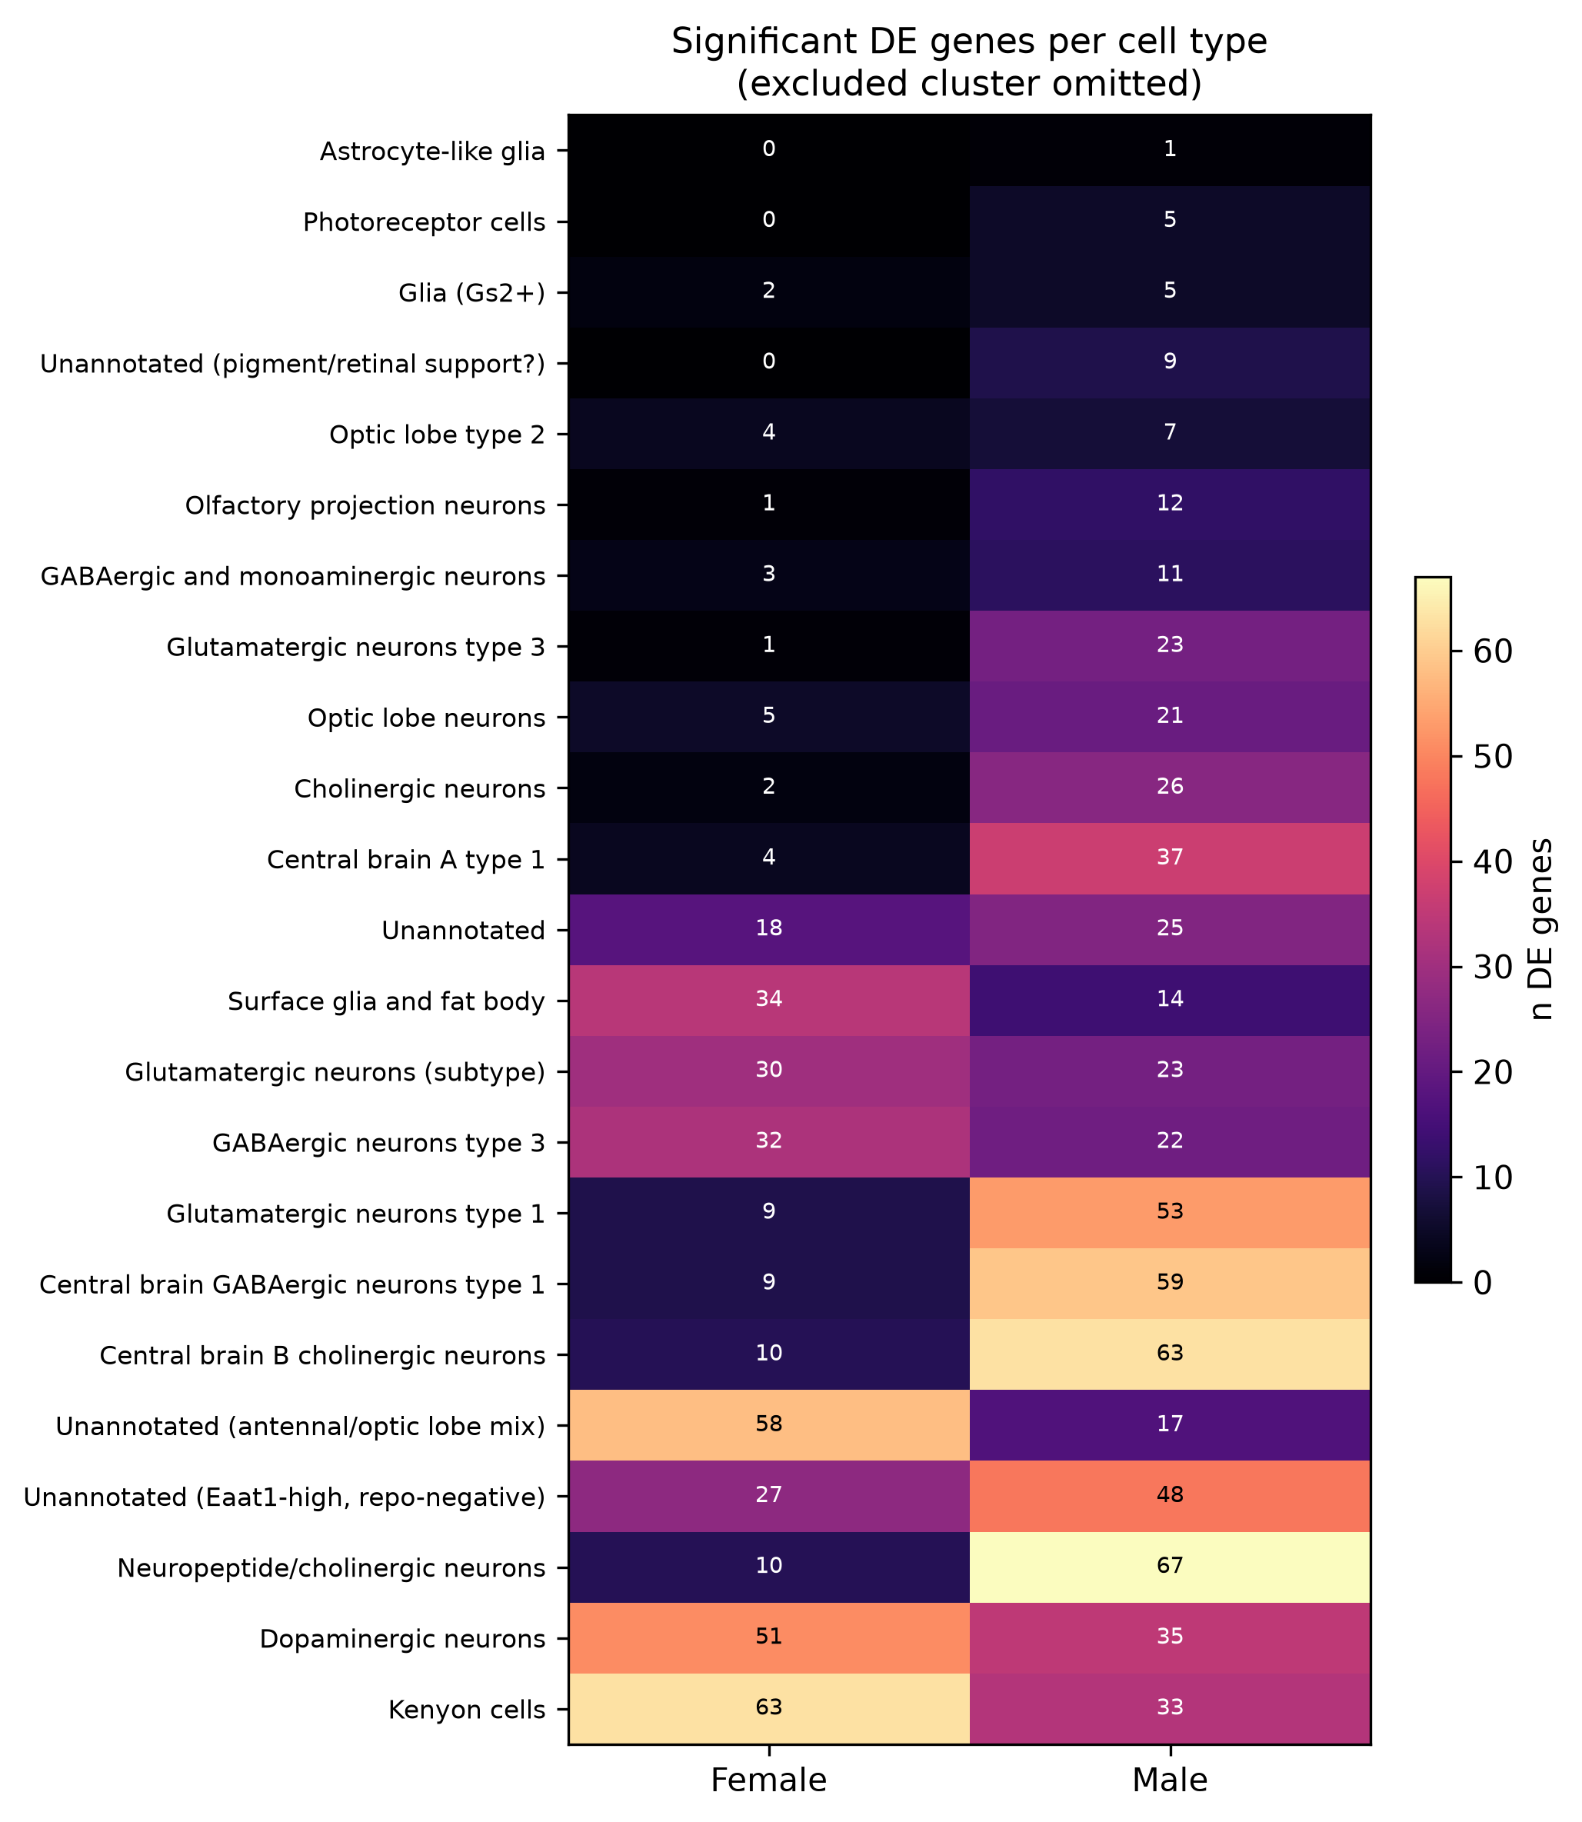

Figure 9. Differentially expressed genes per cell type and sex, with the depth-confounded cluster omitted. Cell types were ordered according to the total response.

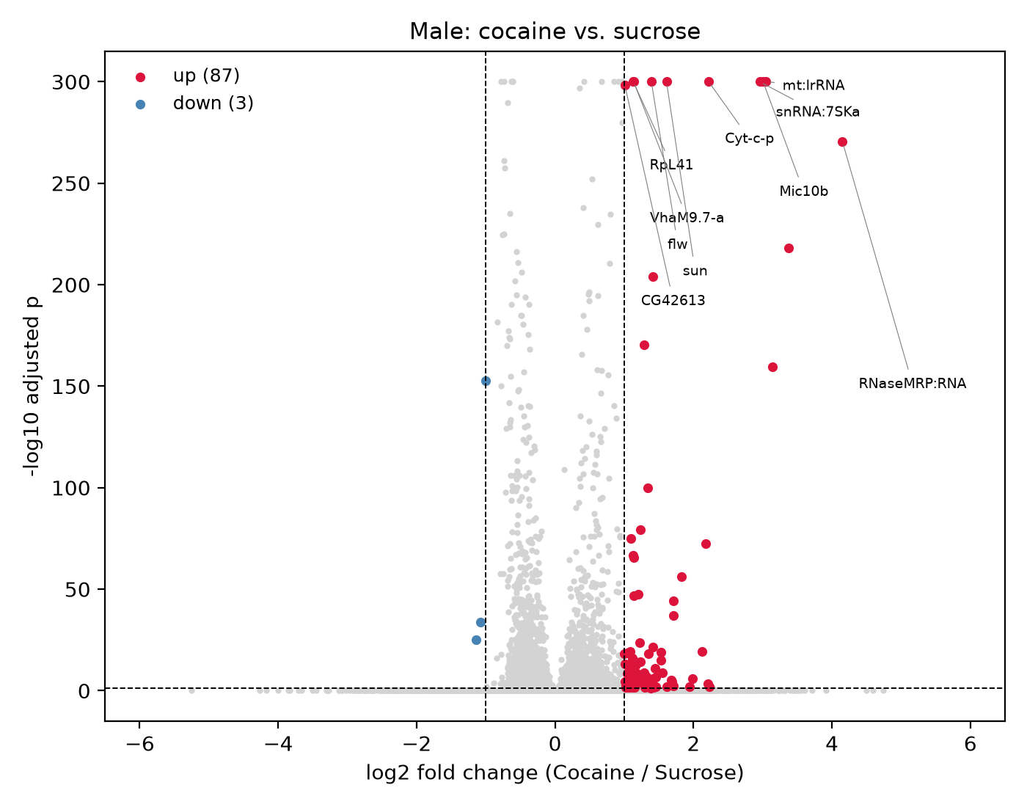

Figure 10. Male: cocaine versus sucrose, pooled across all cells. Genes passing |log2FC| > 1 and adjusted p < 0.05 are highlighted; the ten most significant genes are labelled.

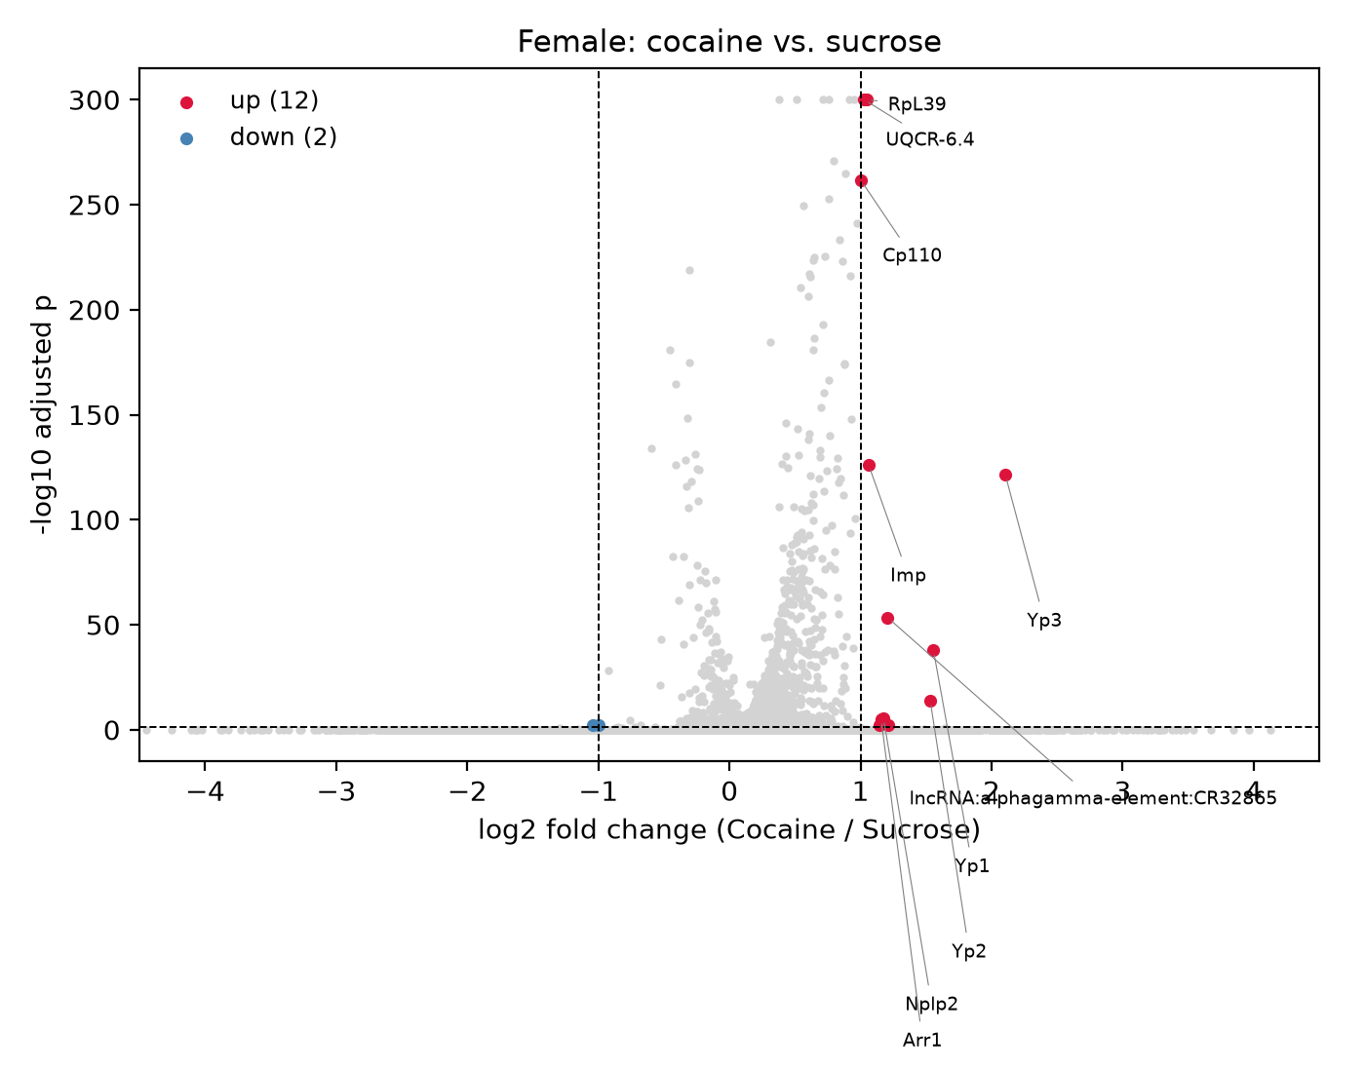

Figure 11. Female: cocaine versus sucrose, pooled across all animals. Axes and thresholds are shown in Figure 10.

3.4 Abundant housekeeping transcripts account for most of the breadth difference

The male genes affecting most clusters were dominated by structural and metabolic transcripts: mt:lrRNA (23 clusters), snRNA:7SKa (22), Cyt-c-p (21), Mic10b (19), mt:srRNA (18), RpL41 (17), sun (17), RNaseMRP:RNA (16).

Twenty-five such genes accounted for 224 of 616 male gene × cluster events (36%), but only seven genes and 27 of 373 events in females (7%). Excluding them reduced the gene × cluster ratio from 1.65-fold to 1.13-fold, breadth from 1.70-fold to 1.29-fold, and rendered the breadth difference non-significant (Mann–Whitney p = 0.72).

Excluding the same classes did not change the pooled unique-gene ratio (6.43-fold to 6.83-fold across progressive exclusion; male counts 90 → 82). The two quantities are distinct: the housekeeping class explains the breadth of the male response but not the pooled gene number.

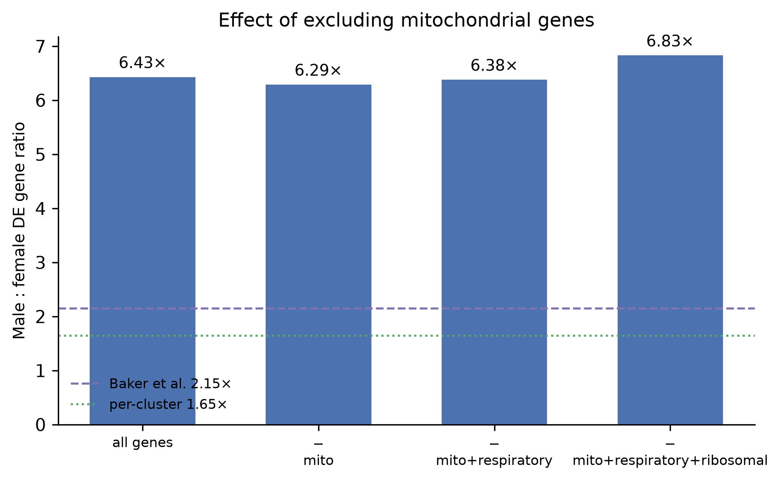

Figure 12. Effect of progressively excluding mitochondrial, respiratory-chain, and ribosomal genes on the pooled male:female ratio. The ratio remained unchanged, indicating that these transcripts do not account for the pooled gene-count asymmetry.

3.5 Leading genes in each sex coincide with technical covariates

In males, the most significant genes were mitochondrial and mitochondria-associated: mt:lrRNA (+3.05 log2FC), Cyt-c-p (cytochrome c), Mic10b (MICOS complex), sun (ATP synthase subunit), VhaM9.7-a (V-ATPase subunit), alongside RNaseMRP:RNA, snRNA:7SKa and RpL41. This coincides with the 6.4-fold difference in mitochondrial content between male treatment arms, absent in females, where mt:lrRNA showed no effect (−0.03). RpL41 is an exception worth noting: it is named by Baker et al. among their globally cocaine-responsive genes and replicates here.

Pathway enrichment showed a similar pattern. Oxidative phosphorylation was the top enriched term in three separate male clusters: dopaminergic neurones (adjusted p = 5.4 × 10⁻⁸), Kenyon cells, and neuropeptide/cholinergic neurones, accompanied by mitochondrial ATP synthesis, respiratory electron transport, and iron–sulfur cluster binding. No respiration term reached significance in any female cluster; female enrichments were axon guidance, synaptic target recognition, and phototransduction. One respiratory subunit (UQCR-6.4) appeared among the top female genes, so the contrast was at the pathway level rather than absolute.

In females, the leading genes were yolk proteins, Yp1–Yp3. These are ambient RNA rather than cellular expression: detection rate was 27.2% of cells in Female_Cocaine_R2 against 3.2–4.9% in sucrose samples, with Female_Cocaine_R1 intermediate at 7.0%, and the signal was distributed across all cell types, including photoreceptors (Yp3 mean 0.663) and Kenyon cells (0.226) — populations that do not transcribe yolk proteins. This is the signature of free transcripts from lysed fat body partitioning into droplets (Young and Behjati 2020), with one dissection disproportionately affected.

ninaE (Rh1 rhodopsin) was also differentially expressed (+1.29 in males), in the opposite direction to the published results. As a photoreceptor gene, its abundance in a brain dissociation depends on retinal carry-over.

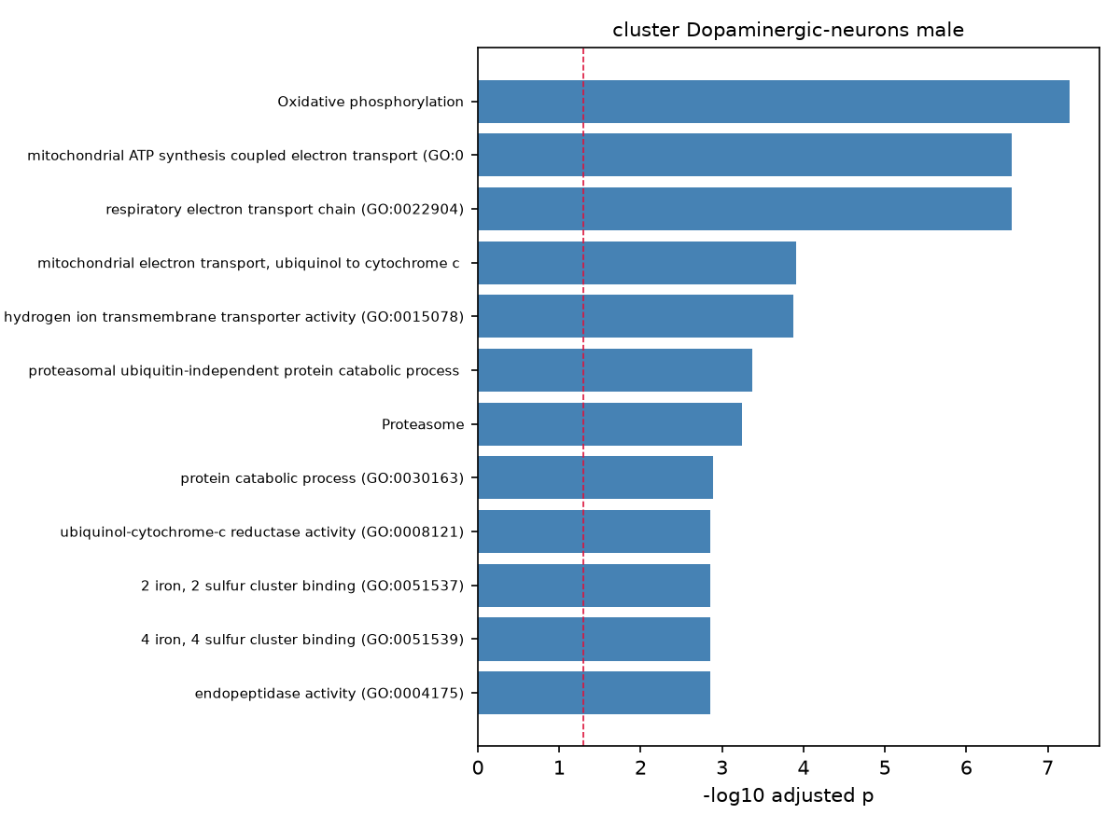

Figure 13. Pathway enrichment for cocaine-responsive genes in male dopaminergic neurones. The respiratory chain is dominant. The dashed line marks the adjusted p = 0.05.

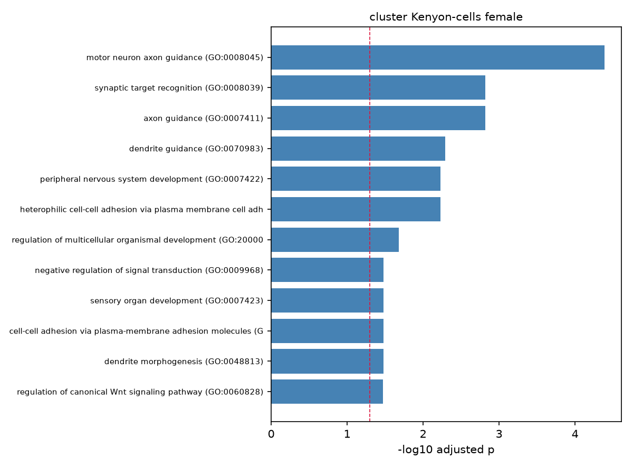

Figure 14. Pathway enrichment for cocaine-responsive genes in female Kenyon cells. No respiration terms appear.

3.6 No individual gene shows a significant sex × treatment interaction

Fitting the expression as sex + treatment + sex:treatment to pseudobulk profiles (9,397 genes, 8 samples) returned no genes with a significant interaction term at FDR < 0.05, and none with a significant main effect of treatment. Of the 90 genes called significant in males by separate per-sex testing, none showed a significant interaction.

With four residual degrees of freedom, this is an expected outcome rather than evidence of absence. Genes with the largest interaction coefficients — Mic10b (2.57), sun (1.19), and Lztr1 (1.02) — are candidates but are not distinguishable from noise at this replicate number. The finding is that the design supports dimorphism in aggregate but cannot establish it for any individual gene, and this limitation applies equally to the original analysis.

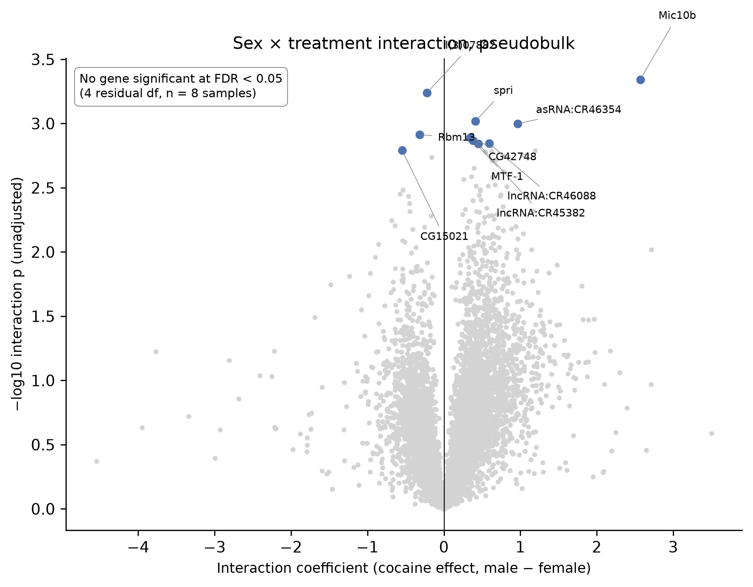

Figure 15. Sex × treatment interaction coefficients from a pseudobulk linear model. Positive values indicate a larger cocaine effect in males. The ten most significant genes are labelled; none survived multiple-testing correction.

3.7 The response ranking is unstable at matched statistical power

Cluster size correlated with the number of DEGs (Spearman ρ = 0.581); therefore, a raw ranking partly measures statistical power. Normalised per 1,000 cells, surface glia and fat body ranked highest among the identified types (58.4), while Kenyon cells fell from first to seventh (25.1).

Downsampling every cluster to 400 cells across three seeds gave: unannotated Eaat1-high cluster 18.0 ± 7.5, central brain B cholinergic neurones 12.7 ± 3.4, surface glia and fat body 11.7 ± 2.6, Kenyon cells 7.3 ± 2.6. Standard deviations were large relative to the means; therefore, ordering beyond the first few positions was not stable. Surface glia was the only cell type ranking highly under all three approaches.

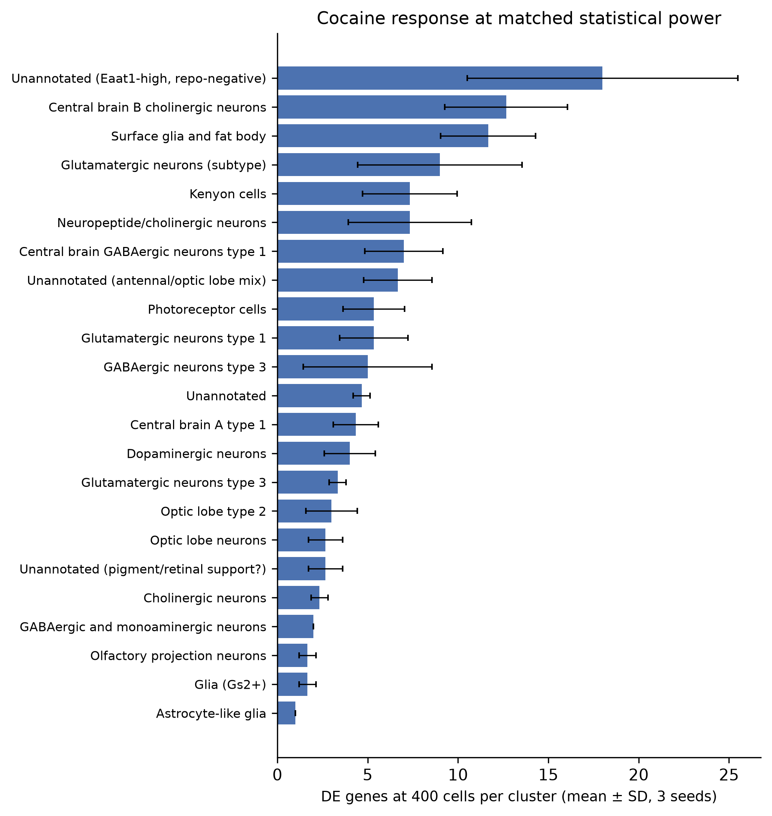

Figure 16. Cocaine response at matched statistical power: every cluster downsampled to 400 cells, mean ± SD over three random seeds. The highest-ranking cluster is one whose identity could not be resolved; among the identified types, the leaders are central brain B cholinergic neurones and surface glia.

3.8 The female response is below its own background

Table 4. Differentially expressed genes under the true treatment split and under two independent null contrasts, within each sex. All contrasts use identical cells, tests, and thresholds.

Sex | Treatment (real) | Replicate axis (null) | Diagonal (null)
Male | 90 | 7 | 14
Female | 14 | 39 | 35

The male response exceeds both nulls by 6- to 13-fold, and is specific to treatment. The female response falls below both. Any alternative grouping of the same four female samples yields more differentially expressed genes than the correct one, and this holds across thresholds (ratio of real to median null: 0.29 at |log2FC| > 0.25, 0.25 at 0.5, 0.38 at 1.0).

Gene identity confirms this pattern. Of the 90 male genes, seven (8%) also appear in a null contrast, and all seven are structural or stress transcripts (28SrRNA-Psi:CR40596, 28SrRNA-Psi:CR45848, snRNA:7SKa, RNaseMRP:RNA, Hsp26, Hsp27, Rh2). Of the 14 female genes, nine (64%) appear in a null, including Yp1, Yp2, and Yp3 — the ambient-RNA genes identified independently in §3.5.

The variance structures were inverted between the sexes. In males, treatment was the dominant source of variation; in females, the replicate axis was, and the female replicate contrast alone yielded 5.6-fold more genes than the equivalent male contrast.

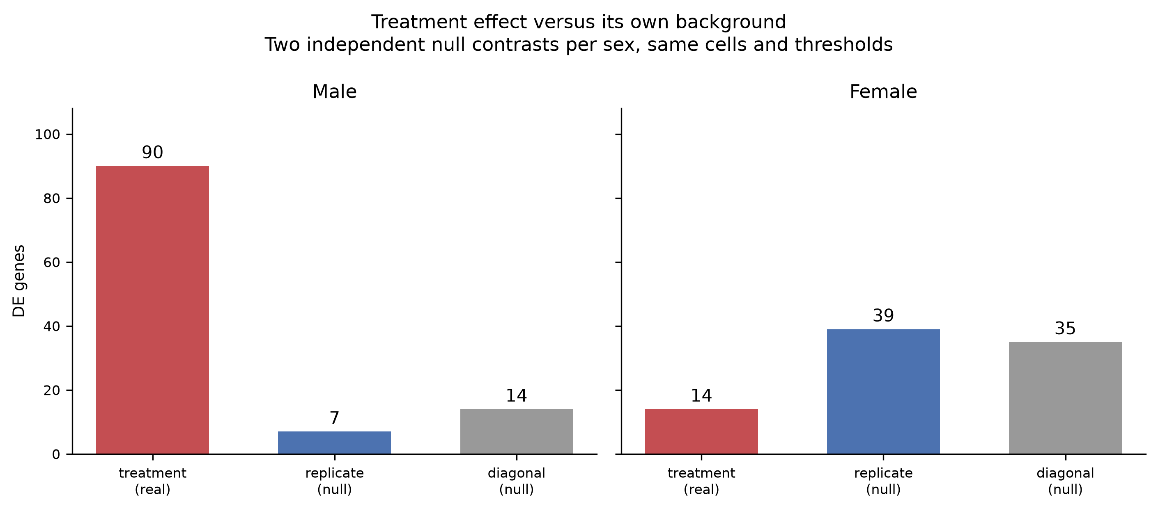

Figure 17. Treatment effect versus its own background. Within each sex, four samples permit two independent null contrasts, in addition to the treatment split. In males, the treatment effect exceeds both nulls; in females, both nulls exceed the treatment effect, and the replicate axis is the largest source of variation. The Y-axes are shared between the panels.

3.9 Cell-level results are directionally corroborated at replicate level

Pseudobulk analysis (n = 2 versus 2) found no significant genes, as expected for this replicate number. Direction agreement with the cell-level test was 100% in both sexes, with Spearman ρ = 0.776 in males (p = 3.0 × 10⁻³) and 0.617 in females (p = 7.7 × 10⁻²). The comparison was restricted to highly variable genes only.

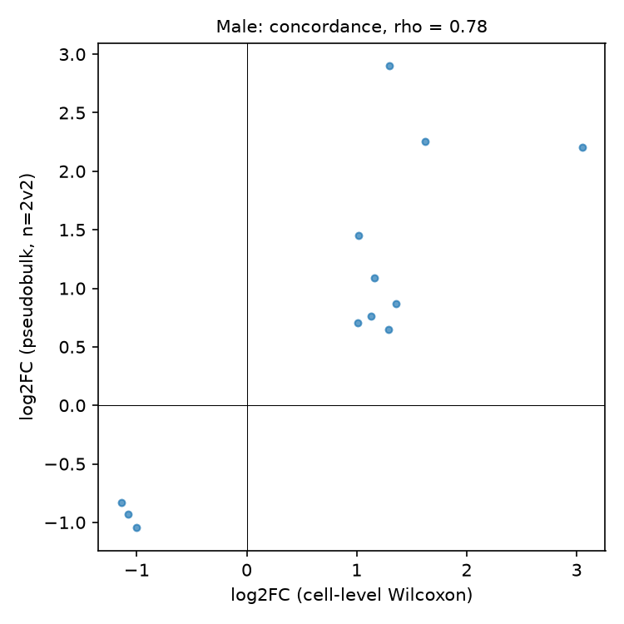

Figure 18. Concordance between cell-level and replicate-level fold changes for genes called significant at the cell level in males.

3.10 Partial reproduction of Baker et al. Figure 3

At the study’s own threshold (|log2FC| > 1.443, equivalent to |ln FC| > 1.0), the gene × cluster matrices contained 46 genes across 23 cell types in males and 45 across 19 in females, against 133 and 54 reported. Venn analysis of the six cell types at the looser threshold gave Jaccard indices of 0.000–0.032, with three cell types sharing no genes between sexes. This study reports little overlap in its divergent clusters; this analysis finds almost none.

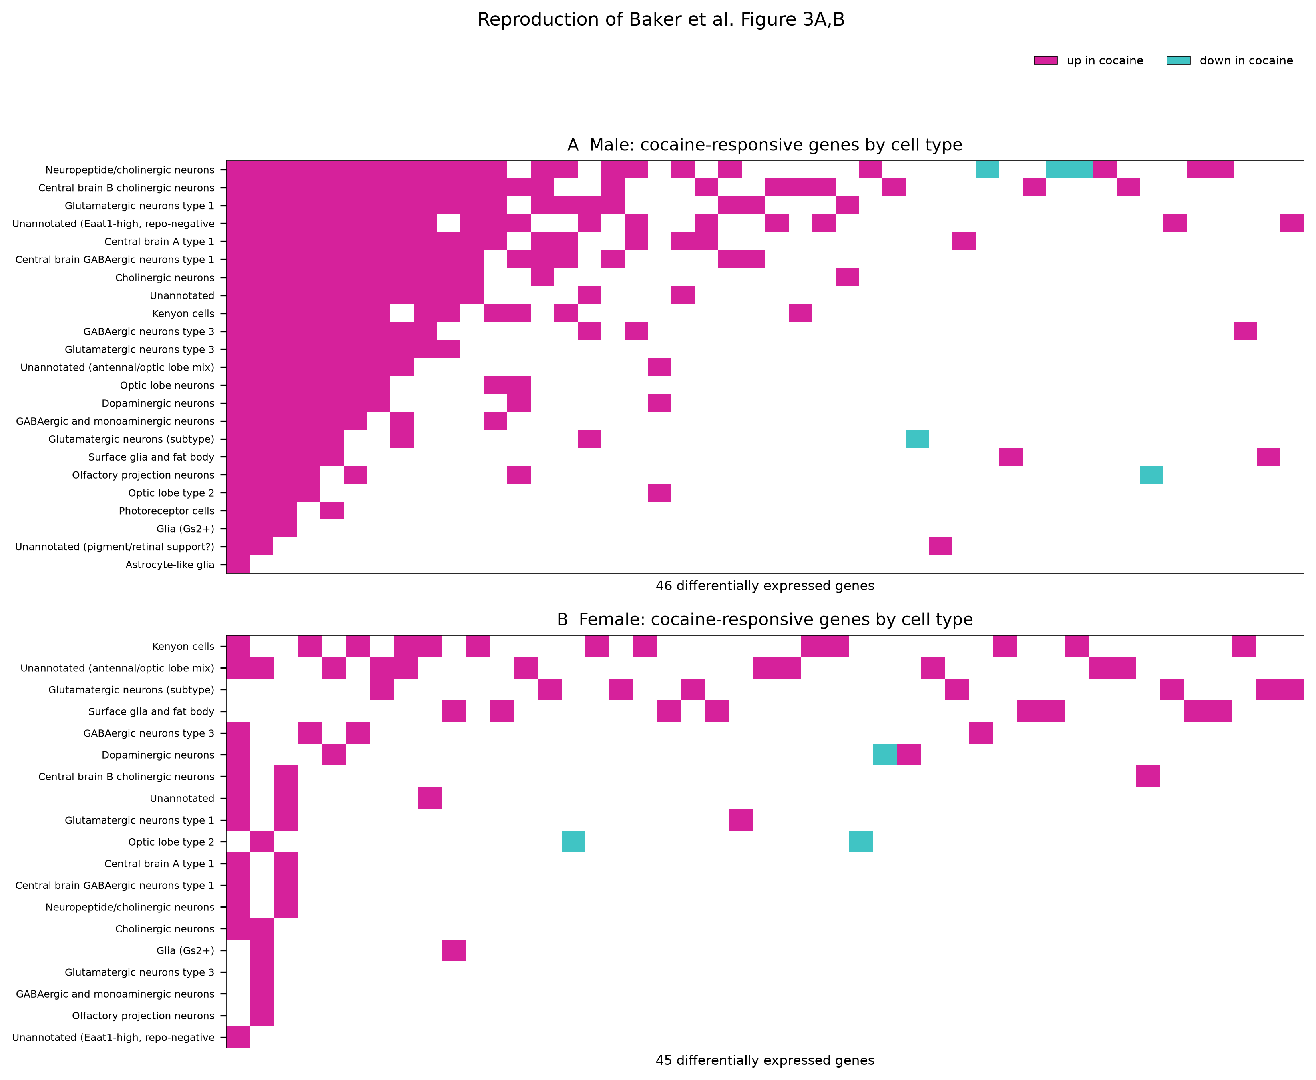

Figure 19. Reproduction of Baker et al. Figure 3A,B. Genes differentially expressed at the threshold of the paper are shown as columns, and cell types as rows; magenta indicates upregulation and turquoise downregulation in cocaine. The block structure at the left of each panel reflects the sort order (genes by cluster frequency, clusters by gene count) rather than missing data.

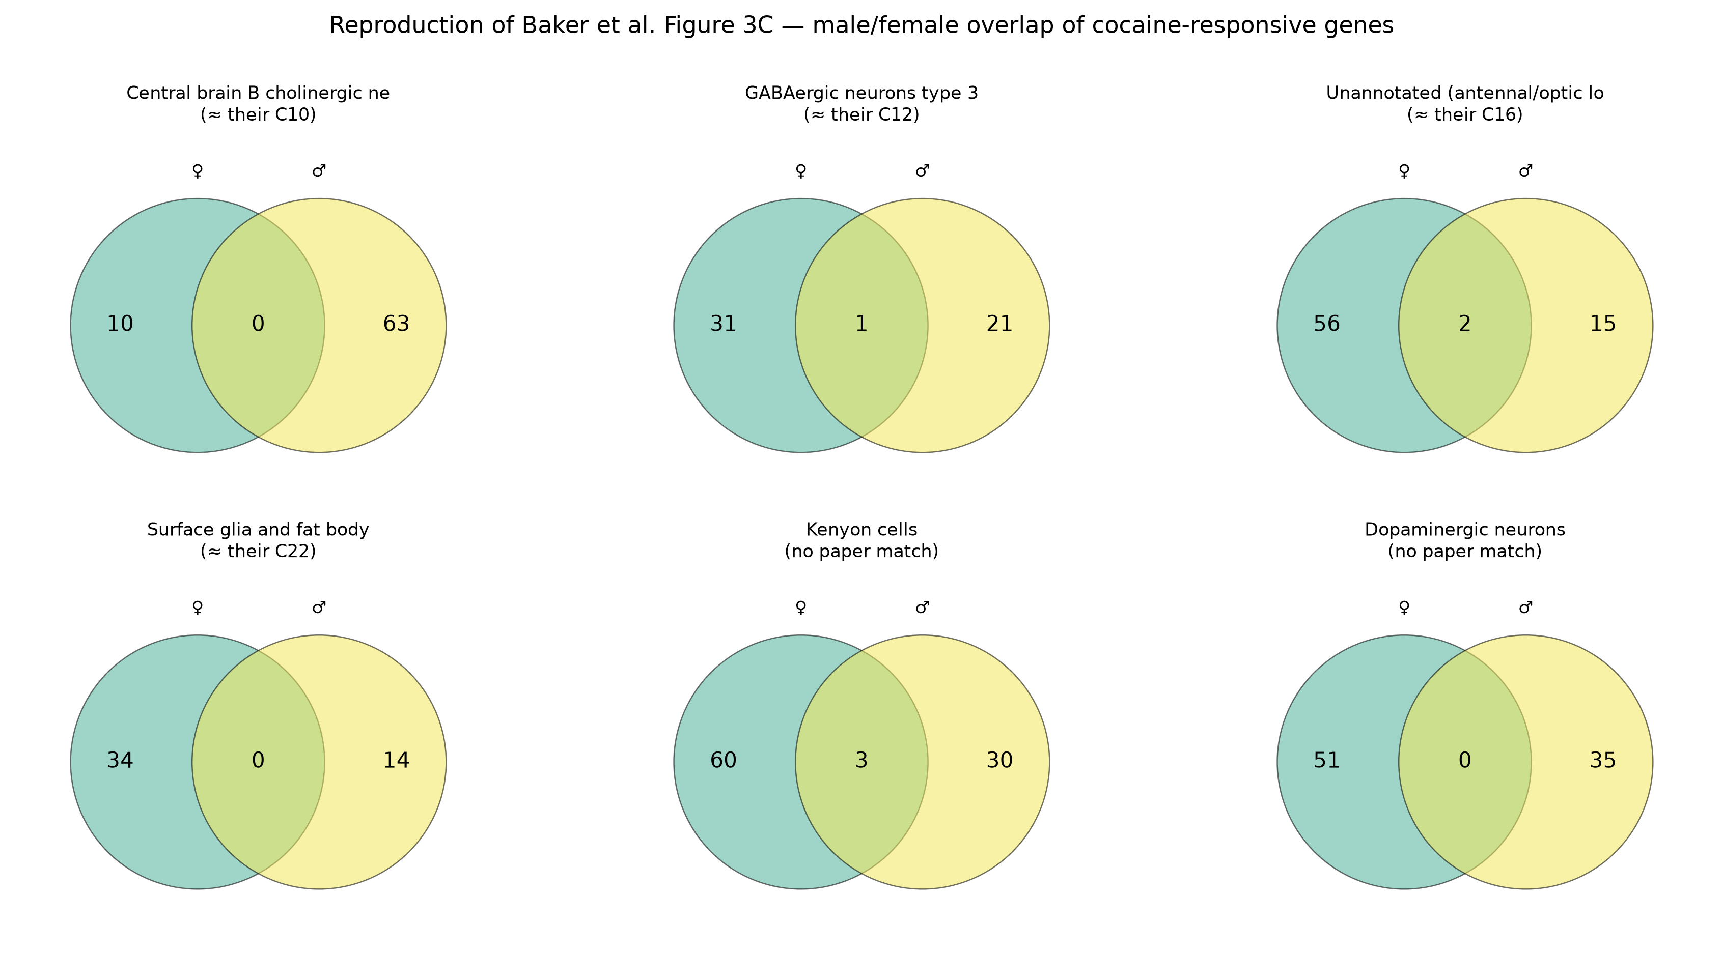

Figure 20. Reproduction of Baker et al. Figure 3C. Overlap between male and female cocaine-responsive gene sets for six cell types, four of which correspond to clusters identified as sexually divergent. The circle areas are fixed and not proportional.

4. Comparison with the original study

Table 5. Finding-by-finding comparison with Baker et al. (2021).

Published finding | This reanalysis | Verdict
86,224 cells after QC | 86,177 (0.05% difference) | Reproduced
36 clusters at resolution 0.8 | 30; reaches 36 at ~1.33 | Partially reproduced
Cluster count plateaus at 0.8 | Monotonic increase, no plateau | Not reproduced
All major cell types represented | 24 of 30 clusters assigned | Reproduced
No cluster dominated by one sample | Max 34.3% vs 12.5% expected | Reproduced
Kenyon cells among top responders | 1st raw, 7th at matched power | Partially reproduced
Surface glia among top responders | 12th raw, 3rd normalised and matched | Reproduced
Astrocytes among top responders | Not assessable (143 cells) | Untested
Male-biased response (2.15×) | 0.97× to 6.43× by metric | Analysis-dependent
Little overlap between sexes | Jaccard 0.000–0.032 | Reproduced
mt:lrRNA cocaine-responsive | +3.05 in males; confounded with mt% | Confounded
RpL41 cocaine-responsive | Replicates | Reproduced
ninaE down after cocaine | Up (+1.29 in males) | Not reproduced
Behavioural assays (Figure 1) | Data not deposited | Not applicable
Coexpression networks (Figures 4–6) | Different toolchain required | Not attempted

5. Critique

5.1 Critique of the original study

The following are methodological observations, not claims that the biology is incorrect. Several reflect conventions that were standard at the time of publication; both key papers on pseudoreplication in single-cell differential expression appeared in the same year.
- Differential expression was performed at the cell level without a replicate-level control. MAST was applied across individual cells, treating approximately 43,000 cells per sex as independent observations when there were two biological replicates per arm. This is now known to inflate false discovery substantially (Squair et al. 2021; Zimmerman et al. 2021), and the pseudobulk cross-check performed here found no significant genes at the replicate level in either sex. The published counts of 691 and 322 should be read as cell-level counts, not as counts of genes for which a treatment effect has been established across animals.
- No background comparison was reported. The permutation control performed here shows that in females, an incorrect grouping of the same four samples produces 2.5 to 2.8 times more DEGs than the correct one. A reader of the original paper has no way to assess whether 322 female genes is many or few, because no such baseline is given. This is the most consequential omission identified.
- Sexual dimorphism is inferred from a comparison of separate gene lists. This paper presents Venn diagrams of male and female DEGs per cluster and interprets low overlap as dimorphism. The difference between "significant in males" and "not significant in females" is not itself a test of difference (Gelman and Stern 2006). A formal interaction test, performed here, identifies no gene meeting that standard — though with n = 2 per arm this is expected and does not by itself contradict the published claim.
- The cluster size was not accounted for in the response ranking. The correlation between cluster size and DE gene count (ρ = 0.581 in this reanalysis) means that a raw ranking partly reflects statistical power. Under size-matched analysis, Kenyon cells fall from first to seventh. The conclusion that Kenyon cells respond especially strongly may partly reflect their abundance.
- Quality-control metrics are not reported per treatment group. The 6.4-fold difference in mitochondrial fraction between male treatment arms, absent in females, can be computed from the deposited data but is not tabulated. Given that the paper’s globally cocaine-responsive gene list includes mt:lrRNA, and that oxidative phosphorylation appears as an enriched pathway in male clusters, this is directly relevant to interpretation.
- Ambient RNA is not assessed. Yolk protein transcripts, which cannot be expressed by neurons, are detected in 27% of cells in one female cocaine replicate against 3–5% in controls. Tools for estimating and removing ambient contamination were available (Young and Behjati 2020).
- This reanalysis does not support the clustering stability argument. The paper states that the cluster number stabilises at a resolution of 0.8. In Scanpy with Leiden clustering, the cluster number increased monotonically, with no plateau. This may be an algorithm-specific property rather than a disagreement about the data.

5.2 Critique of this reanalysis
- Treatment labels were inferred and not verified. Sex was confirmed using two independent marker panels. Treatment assignment was based on the deposition order in the authors’ published code. No computational check could verify which animals consumed cocaine. If that inference is wrong, every treatment comparison here is wrong.
- The permutation control has only two independent nulls per sex. Four samples are permitted. This yields an order-of-magnitude comparison, not a p-value.
- The absence of evidence is not evidence of absence. The fact that the female response is not resolvable above background does not show that female flies do not respond to cocaine. A real effect smaller than the between-sample variation would appear identical.
- Six clusters (15.7% of cells) were left unannotated, including the cluster ranking highest under size-matched analysis. Reference-based label transfer against an existing fly brain atlas would likely resolve several issues and was not attempted.
- The astrocyte comparison was untested rather than negative. The genuine astrocyte-like population identified here contained 143 cells, which was too few for differential expression analysis.
- One cluster was excluded post hoc. The decision to drop cluster 1 was made after observing its depth imbalance, which is a form of analytical flexibility. The reasoning is stated, and the data retained; however, a pre-registered exclusion rule would be stronger.
- Pseudobulk analyses were restricted to a reduced gene set. The concordance check used highly variable genes only (2,000 of 12,189), and the interaction model used 9,397 genes after a minimum-count filter.
- Enrichment used a whole-genome background, which is optimistic for brain-expressed genes.
- No integration or ambient-RNA correction was applied. Both were deemed unnecessary, but neither decision was formally tested.

5.3 What would settle the open questions

More biological replicates. Four flies-worth of preparation per sex cannot distinguish a modest treatment effect from dissection variability, and no statistical method recovers information the design does not contain. Six to eight replicates per arm, with dissection sessions recorded and balanced across treatments, would allow the female question to be answered rather than deferred. Recording and reporting per-sample quality metrics alongside treatment comparisons would allow readers to directly assess confounding.

6. Conclusions

The design-level findings of Baker et al. (2021) were reproduced under an independent pipeline. Cell count after quality control matched to within 0.05%; the clustering recovers the major neuronal and glial populations; the embedding is not driven by batch, sex, or treatment; and a male-biased transcriptional response is recoverable, as is near-zero overlap between the sexes.

The gene-level findings were more fragile. The magnitude of the sex bias varied from 0.97-fold to 6.43-fold depending on whether genes or gene × cluster events were counted and at which threshold. The most significant genes in each sex coincided with measurable technical covariates — mitochondrial content in males and ambient RNA in females. In females, the treatment contrast produced fewer differentially expressed genes than an incorrect grouping of the same samples, meaning that the reported female response could not be attributed to treatment on the basis of these data.

Neither outcome is visible from the published figures. Both can be computed from the deposited data in a few hours. The general lesson is that a differentially expressed gene count reported without a background comparison is difficult to interpret and that in small-n single-cell designs, the background can exceed the signal.

7. References

Bainton RJ, Tsai LT, Schwabe T, DeSalvo M, Gaul U, Heberlein U. 2005. moody encodes two GPCRs that regulate cocaine behaviors and blood–brain barrier permeability in Drosophila. Cell 123: 145–156.

Baker BM, Mokashi SS, Shankar V, Hatfield JS, Hannah RC, Mackay TFC, Anholt RRH. 2021. The Drosophila brain on cocaine at single-cell resolution. Genome Research 31: 1927–1937. doi:10.1101/gr.268037.120

Becht E, McInnes L, Healy J, Dutertre C, Kwok IWH, Ng LG, Ginhoux F, Newell EW. 2019. Dimensionality reduction for visualizing single-cell data using UMAP. Nature Biotechnology 37: 38–44.

Becker JB, Koob GF. 2016. Sex differences in animal models: Focus on addiction. Pharmacological Reviews 68: 242–263.

Butler A, Hoffman P, Smibert P, Papalexi E, Satija R. 2018. Integrating single-cell transcriptomic data across different conditions, technologies, and species. Nature Biotechnology 36: 411–420.

Chang H, Grygoruk A, Brooks E, Ackerson LC, Maidment NT, Bainton RJ, Krantz DE. 2006. Overexpression of the Drosophila vesicular monoamine transporter increases motor activity and courtship but decreases the behavioral response to cocaine. Molecular Psychiatry 11: 99–113.

Corey YL, Quick MW, Davidson QN, Lester HA, Guastella J. 1994. A cocaine-sensitive Drosophila serotonin transporter: cloning, expression, and electrophysiological characterization. Proceedings of the National Academy of Sciences 91: 1188–1192.

Croset V, Treiber CD, Waddell S. 2018. Cellular diversity in the Drosophila midbrain revealed by single-cell transcriptomics. eLife 7: e34550.

Davie K, Janssens J, Koldere D, De Waegeneer M, Pech U, Kreft Ł, Aibar S, Makhzami S, Christiaens V, Bravo González-Blas C, et al. 2018. A single-cell transcriptome atlas of the aging Drosophila brain. Cell 174: 982–998.e20.

DeSalvo MK, Hindle SJ, Rusan ZM, Orng S, Eddison M, Halliwill K, Bainton RJ. 2014. The Drosophila surface glia transcriptome: evolutionary conserved blood–brain barrier processes. Frontiers in Neuroscience 8: 346.

Filošević A, Al-Samarai S, Andretić Waldowski R. 2018. High throughput measurement of locomotor sensitization to volatilized cocaine in Drosophila melanogaster. Frontiers in Molecular Neuroscience 11: 25.

Gelman A, Stern H. 2006. The difference between "significant" and "not significant" is not itself statistically significant. The American Statistician 60: 328–331.

Haas AL, Peters RH. 2000. Development of substance abuse problems among drug-involved offenders: evidence for the telescoping effect. Journal of Substance Abuse 12: 241–253.

Hafemeister C, Satija R. 2019. Normalization and variance stabilization of single-cell RNA-seq data using regularized negative binomial regression. Genome Biology 20: 296.

Highfill CA, Baker BM, Stevens SD, Anholt RRH, Mackay TFC. 2019. Genetics of cocaine and methamphetamine consumption and preference in Drosophila melanogaster. PLoS Genetics 15: e1007834.

Huang W, Massouras A, Inoue Y, Peiffer J, Ràmia M, Tarone AM, Turlapati L, Zichner T, Zhu D, Lyman RF, et al. 2014. Natural variation in genome architecture among 205 Drosophila melanogaster Genetic Reference Panel lines. Genome Research 24: 1193–1208.

Ja WW, Carvalho GB, Mak EM, de la Rosa NN, Fang AY, Liong JC, Brummel T, Benzer S. 2007. Prandiology of Drosophila and the CAFE assay. Proceedings of the National Academy of Sciences 104: 8253–8256.

Kaun KR, Devineni AV, Heberlein U. 2012. Drosophila melanogaster as a model to study drug addiction. Human Genetics 131: 959–975.

Kremer MC, Jung C, Batelli S, Rubin GM, Gaul U. 2017. The glia of the adult Drosophila nervous system. Glia 65: 606–638.

Lukas SE, Dorsey CM, Mello NK, Mendelson JH, Lundahl LH, Sholar M, Cunningham SL. 1996. Reversal of sleep disturbances in cocaine- and heroin-dependent men during chronic buprenorphine treatment. Experimental and Clinical Psychopharmacology 4: 413–420.

Mackay TFC, Richards S, Stone EA, Barbadilla A, Ayroles JF, Zhu D, Casillas S, Han Y, Magwire MM, Cridland JM, et al. 2012. The Drosophila melanogaster Genetic Reference Panel. Nature 482: 173–178.

McClung C, Hirsh J. 1998. Stereotypic behavioral responses to free-base cocaine and the development of behavioral sensitization in Drosophila. Current Biology 8: 109–112.

Pandey UB, Nichols CD. 2011. Human disease models in Drosophila melanogaster and the role of the fly in therapeutic drug discovery. Pharmacological Reviews 63: 411–436.

Squair JW, Gautier M, Kathe C, Anderson MA, James ND, Hutson TH, Hudelle R, Qaiser T, Matson KJE, Barraud Q, et al. 2021. Confronting false discoveries in single-cell differential expression. Nature Communications 12: 5692. doi:10.1038/s41467-021-25960-2

Thurmond J, Goodman JL, Strelets VB, Attrill H, Gramates LS, Marygold SJ, Matthews BB, Millburn G, Antonazzo G, Trovisco V, et al. 2019. FlyBase 2.0: the next generation. Nucleic Acids Research 47(D1): D759–D765.

Traag VA, Waltman L, van Eck NJ. 2019. From Louvain to Leiden: guaranteeing well-connected communities. Scientific Reports 9: 5233. doi:10.1038/s41598-019-41695-z

Wang KH, Penmatsa A, Gouaux E. 2015. Neurotransmitter and psychostimulant recognition by the dopamine transporter. Nature 521: 322–327.

Westermeyer J, Boedicker AE. 2000. Course, severity, and treatment of substance abuse among women versus men. American Journal of Drug and Alcohol Abuse 26: 523–535.

Wolf FA, Angerer P, Theis FJ. 2018. SCANPY: large-scale single-cell gene expression data analysis. Genome Biology 19: 15. doi:10.1186/s13059-017-1382-0

Young MD, Behjati S. 2020. SoupX removes ambient RNA contamination from droplet-based single-cell RNA sequencing data. GigaScience 9: giaa151. doi:10.1093/gigascience/giaa151

Zimmerman KD, Espeland MA, Langefeld CD. 2021. A practical solution to pseudoreplication bias in single-cell studies. Nature Communications 12: 738. doi:10.1038/s41467-021-21038-1

Appendix A. Citation provenance

Citations to Bainton, Becht, Becker and Koob, Butler, Chang, Corey, Croset, Davie, DeSalvo, Filošević, Haas and Peters, Hafemeister and Satija, Highfill, Huang, Ja, Kaun, Kremer, Lukas, Mackay, McClung and Hirsh, Pandey and Nichols, Thurmond, and Wang were taken directly from the reference list of Baker et al. (2021).

Citations to Gelman & Stern, Squair et al., Traag et al., Wolf et al., Young & Behjati and Zimmerman et al. were verified against publisher records.

Not cited because not verified: formal citations for GSEApy, statsmodels, numpy, pandas, and scipy. These are named in the Methods section with version numbers; add the appropriate citations from their documentation before submission.

To confirm against the published article before submission: that Baker et al. report a cluster number stabilising at resolution 0.8, and the exact wording of the overlap claim in the Figure 3C legend.

Appendix B. Data and code availability

Raw data: NCBI Gene Expression Omnibus accession GSE152495.

Analysis code, environment lockfile, result tables, and figure-generating scripts: [insert repository URL].

The count matrices were not redistributed; scripts to rebuild them from GEO are included in the repository.

